1. Introduction

2. Experimental methodology

3. Experimental model

4. Result and discussion

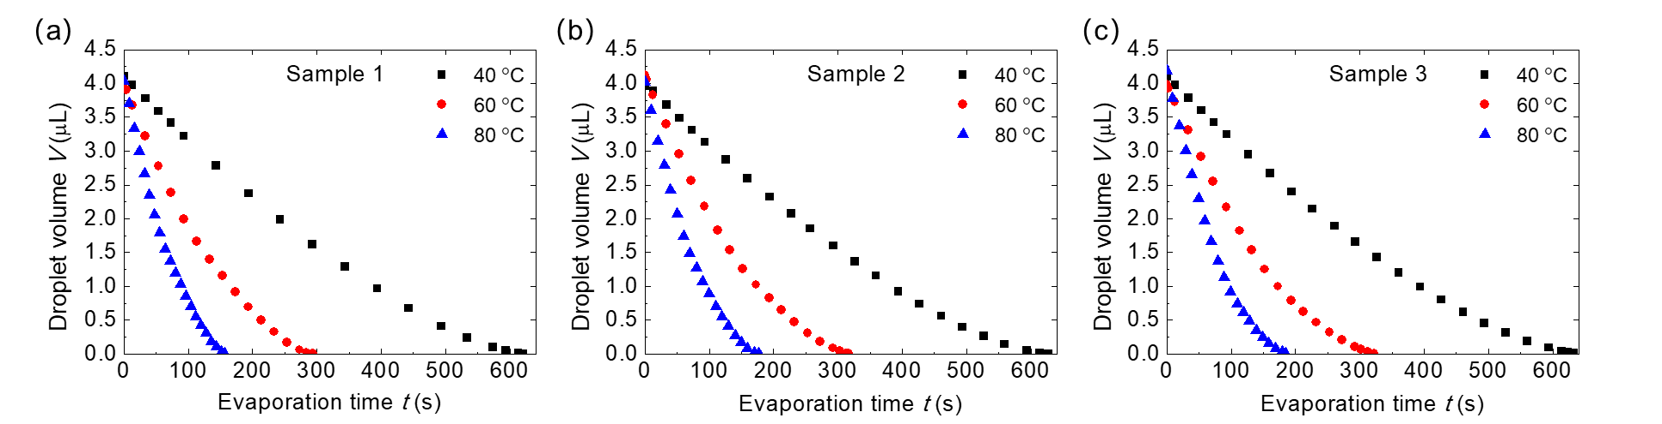4.1. Droplet evaporation dynamics

Figure 1. Temporal evolution of droplet volume on different substrates: (a) sample 1, (b) sample 2 and (c) sample 3. The substrate bases are heated to 40 °C, 60 °C and 80 °C.

The variation of droplet volume with respect to evaporation time on different substrates is shown in Fig. 1. Droplet volume decreases nonlinearly during the evaporation. The total evaporation time decreases with the rise of the substrate base temperature. The total evaporation time increases with the increase of the substrate periodicity when the substrate base temperature is kept the same. Droplet evaporation on sample 3 (60 μm periodicity) has the longest total evaporation time and on sample 1 (40 μm periodicity) has the shortest total evaporation time. This increase of total evaporation time is credited to the increase of the thermal resistance between the droplet base and the substrate, which is caused by the increase of the substrate periodicity. The total evaporation time of droplet evaporation on different sample substrates is shown in Table 1.

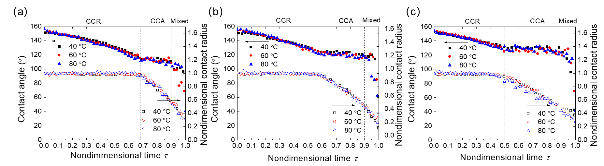Table 1. Total evaporation time for droplet on different substrates with different base temperature.

|  |  |  |
| --- | --- | --- |
| Substrate | Substrate base temperature (°C) | Total evaporation time (s) |
| Sample 1 | |  | | --- | | 40 | | 60 | | 80 | | |  | | --- | | 620.1 | | 293.3 | | 156.8 | |
| Sample 2 | |  | | --- | | 40 | | 60 | | 80 | | |  | | --- | | 627.1 | | 312.2 | | 177.1 | |
| Sample 3 | |  | | --- | | 40 | | 60 | | 80 | | |  | | --- | | 633.3 | | 322.3 | | 184.1 | |

Figure 2. Evolution of droplet contact angle and nondimensional contact radius versus nondimensional time on different sample substrates: (a) sample 1, (b) sample 2 and (c) sample 3. The substrate bases are heated to 40 °C, 60 °C and 80 °C.

The variation of droplet contact angle and nondimensional contact radius with versus nondimensional time is shown in Fig. 2. Here the nondimensional contact radius is defined as the ratio of contact radius and the initial contact radius, and the nondimensional time is defined as the ratio of evaporation time and total evaporation time. It is observed from Fig. 2 that the variation of droplet transient contact angle and nondimensional contact radius is almost the same for droplet evaporation on substrate with different substrate base temperature. For droplet evaporation on sample 1 substrate (Fig. 2 (a)), the droplet contact angle decreases continuously in the first 68% part of the total evaporation time. During this period of time, the contact angle is kept unchanged. This is the constant contact radius mode for the droplet evaporation (CCR mode). After the contact angle reaches to the receding contact angle, the contact angle stops decreasing and keeps unchanged. Meanwhile, the contact radius starts to decrease. This is the constant contact angle mode for the droplet evaporation (CCA mode). The evaporation of droplet is in CCA mode till the nondimensional time approaches 0.9. Then both the contact angle and contact radius decrease and this is the mixed mode for the droplet evaporation. For droplet evaporation on the same substrate with different substrate base temperatures, the evaporation process has almost the same composition of the CCR mode, CCA mode and mixed mode. That means it is the substrate structure that affect the evaporation mode transition and the substrate temperature is not that important. The variations of droplet contact angle and nondimensional contact radius on sample 2 (Fig. 2(b)) and sample 3 (Fig. 2 (c)) substrates are similar to the variation for droplet evaporation on sample 1. The receding contact angle increase with the increase of the periodicity of the substrate. The receding contact angle on sample 1, sample 2 and sample 3 is about 112°, 120° and 128° respectively. Since the initial contact angles of droplet on these three sample substrates are almost the same (about 155°), larger receding contact angle results in the shorter time of the CCR mode. The nondimensional evaporation time for CCR mode on sample 1, sample 2 and sample 3 is about 0.68, 0.6 and 0.5, respectively.

4.2. Evaporation from droplet base

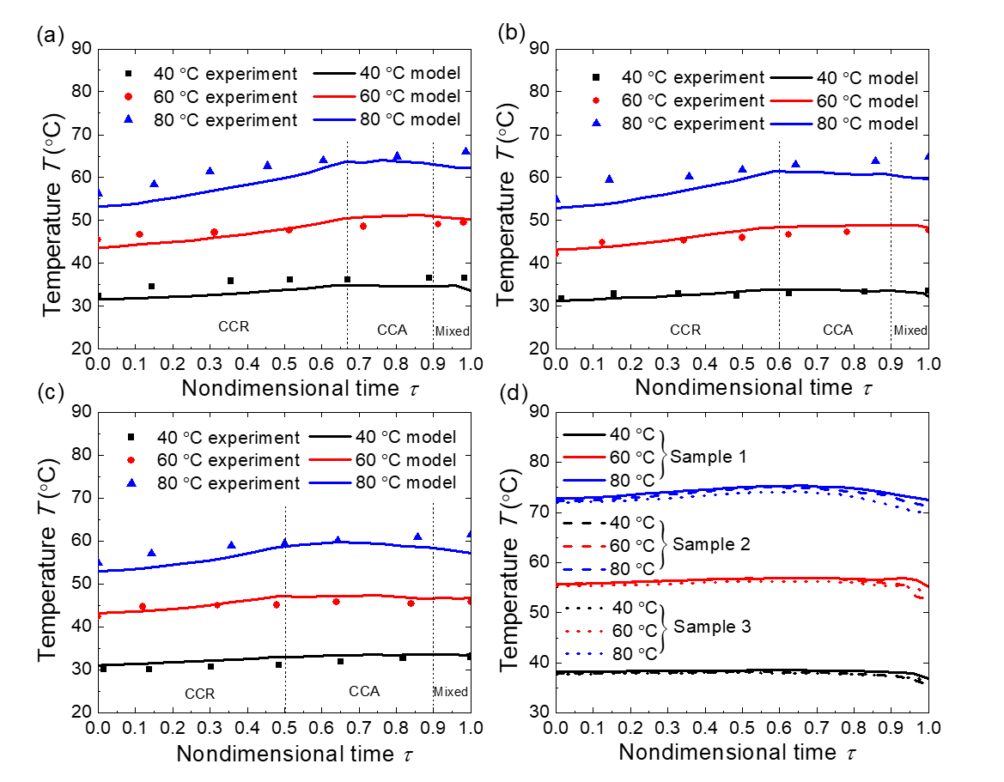Figure 3. (a) Evolution of droplet cap surface temperature on sample 1 substrate. (b) Evolution of droplet cap surface temperature on sample 2 substrate. (c) Evolution of droplet cap surface temperature on sample 3 substrate. The solid lines represent the droplet cap surface temperature calculated by the thermal circuit model and the scatter dots are the experimental results tested by the IR camera. (d) Evolution of droplet base surface temperature on sample 1 sample 2 and sample 3 heated with base temperature 40 °C, 60 °C and 80°C.

In Fig. 3 (a), (b) and (c), we show the evolution of droplet cap surface temperature versus the nondimensional time. The droplet cap surface temperature calculated by the thermal circuit model matches well with the droplet cap surface temperature tested by the IR camera for the evaporation on substrates with substrate base temperature at 40 °C, 60 °C and 80 °C. There is a large temperature difference between the droplet cap surface and the substrate base temperature. This temperature drop is caused by the thermal resistances of the water droplet, the evaporation and the silicon substrate. It is observed that the surface temperature increases in the CCR mode and keeps essentially constant in the CCA mode. Same observation was also demonstrated by Saenz et al [] in their numerical simulation of droplet evaporation on heated surfaces. During the CCR mode, the volume of the droplet decreases and thermal resistance of the droplet decreases. The droplet cap surface gets closer to the substrate and thus the droplet cap surface temperature increases. In the CCA mode, the contact area between the droplet and the substrate decreases. As a result, less heat is transferred into the droplet, which hinders the temperature increase of the droplet. The combination effects of the decreasing contact area and decreasing water droplet thermal resistance result in the unchanged average surface temperature of the droplet cap surface. In the Mixed mode, the droplet volume is very small (<0.05 μL), we don’t consider the mixed mode in this discussion.

In Fig. 3 (d), we show that average temperature of the droplet base surface on different sample substrates and with different substrate base temperatures. We can find that there is an unneglectable temperature mismatch between the droplet base surface temperature and the substrate base temperature. Though there will be a temperature drop through the substrate because of the substrate thermal resistance, the large thermal conductivity of silicon (300 W/mK []) means that the temperature drop caused by the silicon thermal resistance is small (< 1°C based on our calculating results). However, the temperature mismatch between the droplet base surface and the substrate base surface is about 2.5 °C, 4.4 °C and 7.5 °C on substrates with base temperature 40 °C, 60 °C and 80 °C. The main temperature difference between the droplet base surface and the substrate is caused by the evaporation from the droplet base surface.

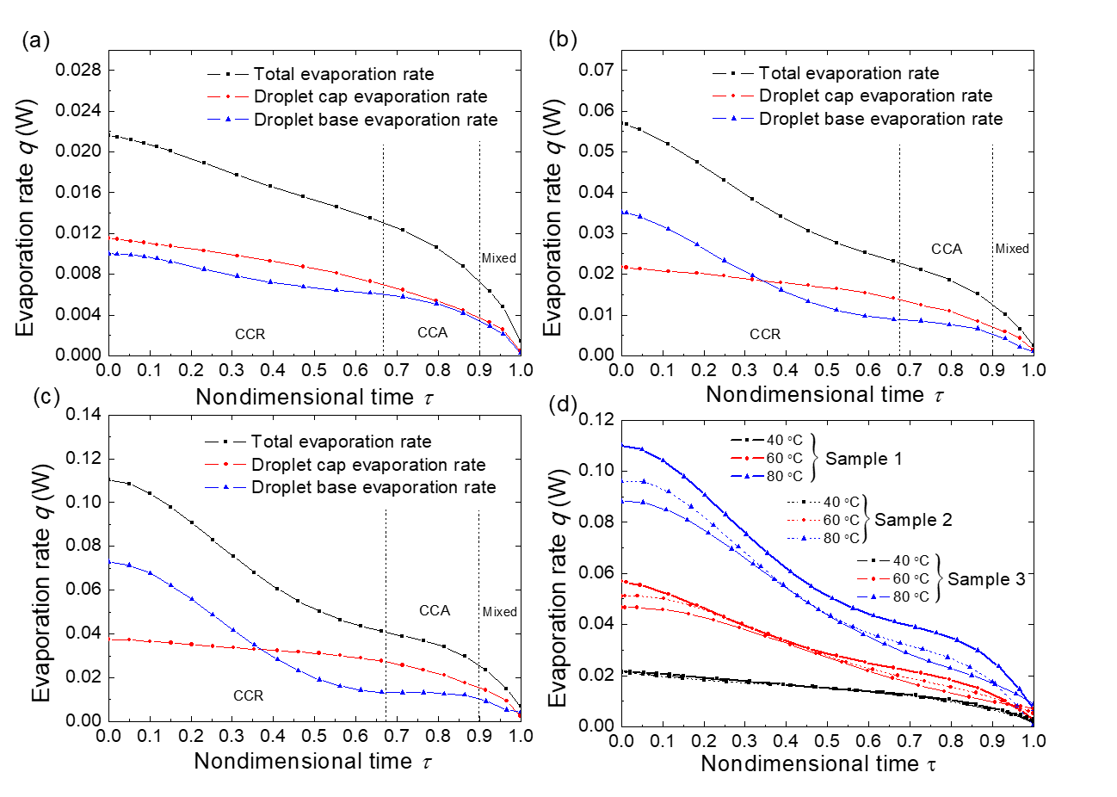

Figure 4. (a) Total evaporation rate, droplet cap surface evaporation rate and droplet base surface evaporation rate of droplet evaporation on sample 1 substrate with 40 °C substrate base temperature. (b) Total evaporation rate, droplet cap surface evaporation rate and droplet base surface evaporation rate of droplet evaporation on sample 1 substrate with 60 °C substrate base temperature. (c) Total evaporation rate, droplet cap surface evaporation rate and droplet base surface evaporation rate of droplet evaporation on sample 1 substrate with 80 °C substrate base temperature. (d) Total evaporation rate of droplet evaporation on sample 1, sample 2 and sample 3 substrates with substrate base temperature at 40 °C, 60 °C and 80 °C.

In Fig. 4 (a), (b) and (c), we show the total evaporation rate, droplet cap surface evaporation rate and droplet base surface evaporation rate of droplet evaporation on sample 1 substrate at substrate base temperature 40 °C, 60 °C and 80 °C. The evaporation rate of droplet on sample 2 and sample 3 substrates is given in the supporting information. The droplet total evaporation rate is calculated by the droplet volume decreasing rate with experimental transient droplet volume. The droplet cap surface evaporation rate is calculated by the diffusion driven model with the interface temperature predicted by the thermal circuit model. The droplet base evaporation rate is the difference value of the total evaporation rate and the droplet cap surface evaporation rate based on the energy balance model. With the increase of the substrate base temperature (from 40 °C to 80 °C), both the evaporation rates from the droplet cap surface and droplet base surface temperature increase at the same nondimensional time. Also, both the evaporation rates from the droplet cap surface and the droplet base surface decrease during the droplet evaporation process for droplet evaporation on a substrate with constant base temperature. It is observed that the decrease of the droplet cap surface evaporation rate in the CCR mode is very slow and the decrease of the droplet base surface evaporation rate in the CCA mode is slow. In the CCR mode, the decrease of the evaporation rate from the droplet cap surface is caused by the decrease of the droplet contact angle. The contact area between the droplet and the substrate keeps unchanged and the thermal resistances between the droplet base the substrate is also unchanged. The decrease of the droplet total evaporation rate means that less heat is transferred from the substrate to the droplet. With the substrate base temperature and the thermal resistances between the droplet and substrate keep unchanged, the decrease of the total evaporation rate is caused by the decrease of the temperature difference between the droplet base surface and the substrate base surface. In other words, the decrease of the total evaporation rate will cause the increase of droplet base surface temperature, which is also shown in Fig. 3 (d). The increase of droplet base surface temperature will cause the increase of the droplet cap surface temperature which leads to the increase of the evaporation rate from the droplet cap surface temperature. The effect of droplet cap surface temperature increase mitigates the effect of the droplet contact angle decrease on the decrease of the evaporation rate from the droplet cap surface. The combination effects of the contact angle decrease and the droplet cap surface temperature increase determine the slow decrease of the evaporation rate from droplet cap surface in the CCR mode. In the CCA mode, the average temperature of the droplet cap surface temperature keeps essentially constant which is different from the cap surface temperature change in the CCR mode. Meanwhile, both the droplet cap surface temperature and the droplet base temperature decreases. Thus, the evaporation rate of droplet cap surface decreases quickly and the evaporation rate from the droplet base surface decreases slowly. In summary, in CCR mode the decrease of the total evaporation rate of the droplet is mainly caused by the decrease of evaporation rate from the droplet base surface mode and in CCA mode, the decrease of the total evaporation rate is mainly caused by the decrease of the evaporation rate from the droplet cap surface.

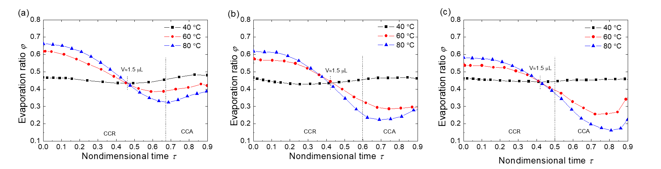 The total evaporation rates are not the same for droplet evaporation on different substrates with the same substrate base temperature, as shown in Fig. 4 (d). Droplet evaporation on sample 1 (40 μm periodicity) substrate has the maximum evaporation rate and on sample 3 (60 μm periodicity) substrate has the minimum evaporation rate. Because of the different substrate periodicity, the solid-liquid interface areas are different for droplets evaporation on different sample substrates. Since droplets evaporation on different sample substrates have essentially the same apparent contact area (base area of the droplet), small substrate periodicity means fewer vapor cavities between the droplet and the substrate and more solid-liquid interface area. The larger solid-liquid interface area results in the higher droplet evaporation rate for evaporation with the same substrate base temperature.

Figure 5. Evaporation ratio *φ* of droplet base surface with respect to nondimensional time for different substrate temperatures on different sample substrates.

The evaporation ratio of droplet base surface with respect to nondimensional time for different substrate base temperatures on different sample substrates is shown in Fig. 5. Evaporation ratio *φ* is the ratio of evaporation rate from the droplet base surface and total evaporation ratio which are given in Fig. 4. It is observed that the evaporation ratio *φ* decreases in the CCR mode and increase in the last period of CCA mode. That is because of the difference decrease rate of the evaporation ratio from the droplet cap surface and droplet base surface. It has been discussed that the decrease of the total evaporation rate in CCR mode is mainly caused by the decrease of the evaporation ratio from the droplet base surface. The quick decrease of evaporation rate from the droplet base surface determines the decrease of the evaporation ratio in the CCR mode. In the CCA mode, the decrease from the droplet base surface is slow and the main decrease of the total evaporation rate is from the droplet cap surface. The slow increase of the evaporation rate from the droplet base surface determines the increase of evaporation ratio. The evaporation ratio *φ* increases with the substrate temperature for droplets with large volume (larger than 1.5 μL). The increase of substrate temperature will cause a direct temperature increase of the droplet base surface and the temperature increase of the droplet base surface will then cause the temperature increase of the droplet cap surface. Due to the thermal resistance in the droplet bulk, the temperature increase of the droplet cap surface is smaller than that at the droplet base with the increase of the substrate temperature. Thus, the substrate temperature increase leads to a higher evaporation rate increase at the droplet base surface for large volume droplet. As a result, the evaporation ratio *φ* increase with the rise of the substrate temperature for droplet with large droplet volume. For droplets with small volume (smaller than 1.5 μL), the evaporation ratio *φ* decreases with the increase of the substrate temperature. Because of the small volume, the thermal resistance of the droplet bulk is small and the increase of the substrate temperature will cause a higher temperature increase at droplet cap surface for droplets with small volume. Thus, the increase of the substrate temperature causes a higher evaporation rate increase than at the droplet base surface for droplets with smaller volume. As a result, the evaporation ratio *φ* decreases with rise of the substrate temperature for droplet with small volume.

4.3. Effective conductivity of water droplet at high temperature

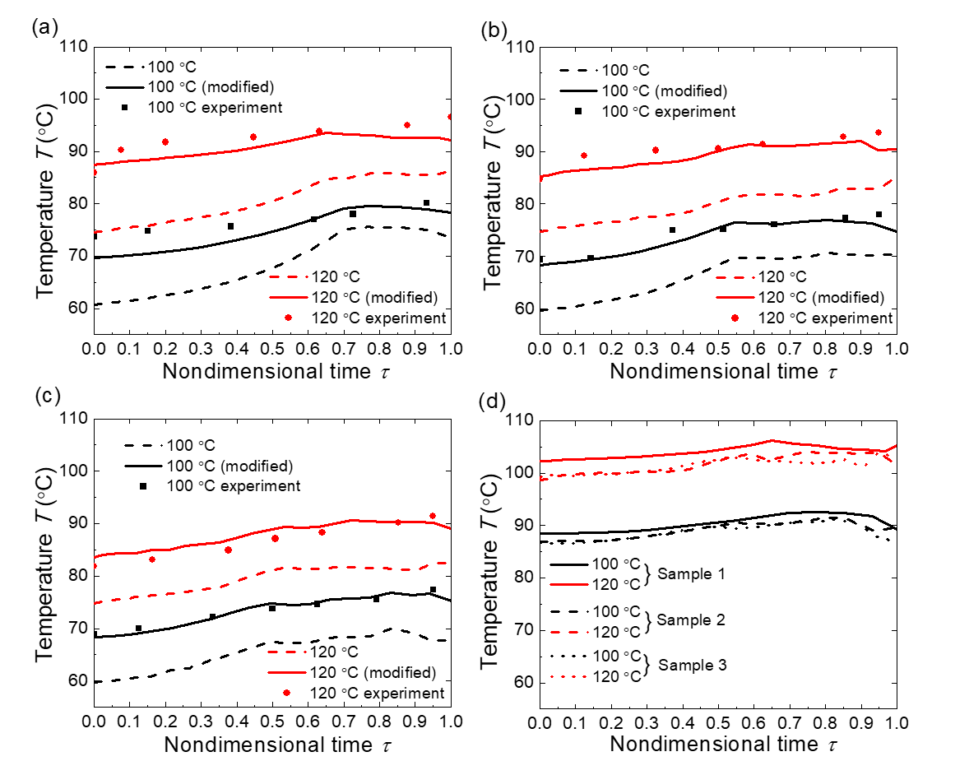

Figure 6. (a) Evolution of droplet cap surface temperature on sample 1 substrate. (b) Evolution of droplet cap surface temperature on sample 2 substrate. (c) Evolution of droplet cap surface temperature on sample 3 substrate. The dash lines represent the droplet cap surface temperatures calculated by the thermal circuit model, the solid lines represent the droplet cap surface temperatures modified with total average temperature and effective conductivity and the scatter dots are the experimental results tested by the IR camera. (d) Evolution of droplet base surface temperatures on sample 1 sample 2 and sample 3 heated with base temperature 100 °C and 120°C.

Fig. 6 (a), (b) and (c) show the droplet cap surface temperatures for droplet evaporation on different substrates with substrate temperature at 100 °C and 120 °C. The dash lines are the droplet cap surface temperatures calculated by the thermal circuit mode. For droplet evaporation on substrate with low temperatures (40-80 °C), the droplet cap surface temperatures calculated by the thermal circuit model match well with experimental results. However, for evaporation on high substrate base temperature, there is large derivation between the calculating results and the experimental results. This derivation is because the fluid flow of the droplet is not taken into account in the thermal circuit model. For droplet evaporation on substrate with substrate base temperature from 40 °C to 80 °C, the effects of droplet flow in the droplet are not significant for the droplet cap surface temperature. As mentioned by Dash et al [], the characteristic velocity of fluid in 3 μL water droplet evaporation on 40- 60 °C substrate is of tens of microns per second and the Peclet number is less than 1. Thus, it is reasonable not to consider the internal convection of the water droplet when calculating the droplet cap surface temperature in our study for low substrate base temperature evaporation (40-80 °C). With the increase of the substrate base temperature, more heat is transferred through the droplet and the temperature difference between the droplet top and bottom surface becomes larger. Fluid motion driven by the temperature difference in the droplet becomes violent and the characteristic velocity of the fluid in the droplet increases. Thus, we need to take the fluid motion inside the droplet into account when calculating the droplet cap surface temperature.

In this study, the IR camera is placed on the top side of the droplet and the experimental result temperature tested by the IR camera is the temperature of the half top surface of the droplet. Correspondingly, in the thermal circuit model, the average temperature of the droplet half top surface is calculated and compared with the experimental data. The droplet flow will mitigate the temperature difference between the droplet top and bottom surface. To take into account the droplet flow, we calculate the overall average temperature of the droplet cap surface instead of only the half top surface. The modified calculating temperature results match well with the experimental data for droplet evaporation on sample 1, 2 and 3 with substrate base temperature at 100 °C as shown in Fig. 6 (a), (b) and (c).

But there is still large derivation between the results for droplet evaporation on substrates with base temperature at 120 °C. The effects of convection heat transfer in the water droplet can’t be neglected. In the thermal circuit model, droplet is divided into layers and only the conductive thermal resistance is calculated when calculating the droplet temperature. Convection in the water droplet will enhance the heat transfer in the droplet and reduce the total thermal resistance of the droplet. Because of the complexity of internal flow, it is not practical to analyze the convection heat transfer base on the droplet velocity. Alternatively, an effective value of the water thermal conductivity is used to consider the heat transfer of both the convection and conduction. An effective thermal conductivity $k_{eff}=n∙k_{w}$ is replaced in the thermal circuit model to calculate the droplet cap surface temperature. The minimum value of *n* that allows the average absolute difference between the model temperature and the experimental temperature less than 2 is chosen as the coefficient to the effective conductivity.

$$\overline{\left|T_{model}-T_{expt}\right|}≤2 °C$$

The coefficient for the effective thermal conductivity for droplet evaporation on sample 1, 2 and 3 at 120 °C substrate base temperature is about 3.2, 2.9 and 2.7 respectively.

The substrates are heated to a high temperature over the boiling temperature of the water droplet. However, no water boiling is observed in the droplet even when the substrate temperature is about 120 °C. That is because of the effect of evaporative cooling at the droplet base. Evaporation at the droplet base surface will cool down the surface temperature and we calculate the average temperature of the droplet base surface as shown in Fig. 6 (d). For droplet evaporation on 100 °C substrate, the base surface temperature is about 88 °C and for droplet evaporation on 120 °C substrate, the base surface temperature is about 102 °C. Moreover, vapor flow underneath the droplet will further cool the droplet base surface down and the droplet base temperature always is lower than the boiling temperature. That accounts for the delay of onset boiling for droplet evaporation on heated substrate.

Conclusion